# Android Widgets

# Android Layouts

## Need

* A lot of vendors are available for Android devices.
* Each device has different dimensions, sizes, and configuration
* Static UI cannot work on all devices.
* The solution is to use Layouts in Android which are containers to hold other widgets or views with a set of rules.

Layout

Widget

View Group

View

## Types of Layouts

1. Constraint Layout
2. Linear Layout
3. Grid Layout
4. Frame Layout
5. Scroll View Layout
6. Relative Layout

## Constraint Layout

* The Default layout of every android application.
* It locks the element on all four sides.
* To center any element, place 0 to left and right constraints.

## Linear Layout

* It is used in most mobile applications right now.
* It is also the simplest one as well the oldest one.
* It resembles much like Flow Layout in java.
* It is highly responsive.

### Properties

* orientation
  + How the elements should flow.
  + Vertical or horizontal
  + Default is horizontal.
* gravity
  + How the elements inside the layout should be placed.
  + Resembles much like alignment or float in HTML and CSS.
  + Start, end, center, and so on.
* Weight sum
  + Optional parameter to achieve responsiveness
  + Any real number for its value
  + Give weight to the child elements using weight property



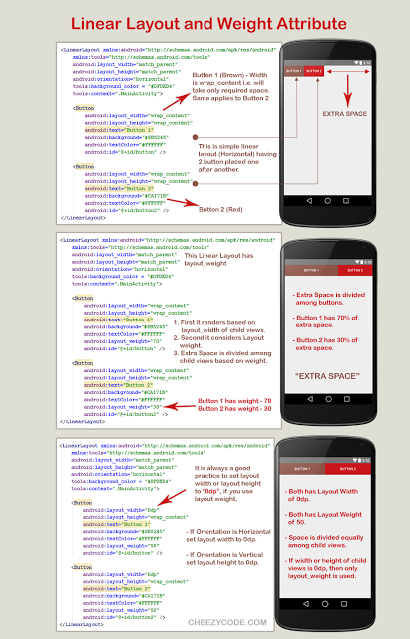



## Grid Layout

It is similar to the tables in HTML. You have to provide the number of rows and columns to create it. Then just place the elements and it will all be adjusted accordingly into the grid. However, you can also set the position of any element by yourself if you want. You can also span the rows or columns to one or more cells to the total if you want exactly same as in HTML.

